Extinction Rates in Turtles Based on Habitat Type

Evolution 461

Final Paper

Lauren Oxford

9 April 2020

**Introduction**

It is no secret that the population of certain turtle species are seeing decreasing numbers of individuals and the causes can be traced back to many things. The decline can be explained by habitat destruction, climate change, turtles being used for food and as pets, and the many diseases that kill them.

The inspiration for this paper was the *Gopherus agassizi*i (Desert Tortoises) of the Mojave Desert and how their population decline might be caused by construction and residential development. The plans for the future involve large amounts of renewable energy in every way, shape, and form. Specifically, the Mojave Desert is a great place for sources like solar and wind energy. Over the next 50 years, the western United States government officials have plans to develop broad scale projects such as the Desert Renewable Energy Conservation Plan (Farnsworth et al. 2015). Projects and plans like these can be seen globally in many different habitats of turtles. Habitat destruction is one of the many problems hurting turtle populations.

*Malaclemys terrapin* (Diamondback turtles) in the Carolinas have seen habitat destruction because the coast is a huge industry for tourism and people’s houses. The Diamondback turtle has also been a source of food for people for many years destroying their populations (Converse et al. 2017). Sea turtles are also being taken advantage of because their home is covered in trash and climate change has changed water temperatures. (Awkward)

The purpose of this paper is to explore the evolutionary hypothesis that the extinction rates of turtles are directly correlated to their habitat type. I will explore data for many species of turtles and their habitat types. To answer the questions of how population decline is affecting the evolutionary development of turtles and how a population regains its numbers after reaching an endangered or extinct rating.

**Methods**

Data was collected from the official website of the International Union for Conservation of Nature and used for the assessment data for all the species of turtles.

To create the bar graph (figure #1) in the results section, I used R and multiple functions within it. I used the realm and red list category data from IUCN and made a graph that shows the population rates for each assessed species.

**Results**

The results of figure #1 show that 260 species of turtle assets by the IUCN are mostly decreasing in population size. The Nearctic realm is a biographical realm that covers most of North America including: Greenland, Central Florida, and the highlands of Mexico. Figure #1 shows that the Nearctic has turtles with mostly an endangered red list category rating, with moderate vulnerable, threatened, and extinct ratings. The Afrotropical realm covers the majority of the Arabian Peninsula, African South, the Sahara Desert, Madagascar, southern Iran, southwestern Pakistan, and the western islands of the Indian Ocean. In figure #1, Afrotropical rates high with species at vulnerable and critical ratings, with the other categories topping at 7 species. The Australasian realm covers Australia, New Zealand, and surrounding small islands. In figure #1, this realm has little data with some vulnerable, low risk, and extinct species. This tells me that the region of Australia and New Zealand either do not have a lot of species of turtle or the area is properly explored and examined. The Neotropical realm covers the entire South American temperate zone. In the graph below, most species are rated vulnerable with high numbers in threatened and critical. The realm has highest species diversification compared to the other realms in the IUCN dataset. The Palearctic realm covers Europe, Asia (north of the Himalaya foothills), northern Africa, and the northern parts of the Arabian Peninsula. This realm covers the most area and has a small number of species of turtle. The turtles that do live in this realm rate mostly as critical. The Indomalayan realm covers South and South east Asia and has the second highest species diversification according to this data. The graphs shows that most of the turtles show high ratings in the vulnerable, critical, and extinct categories.

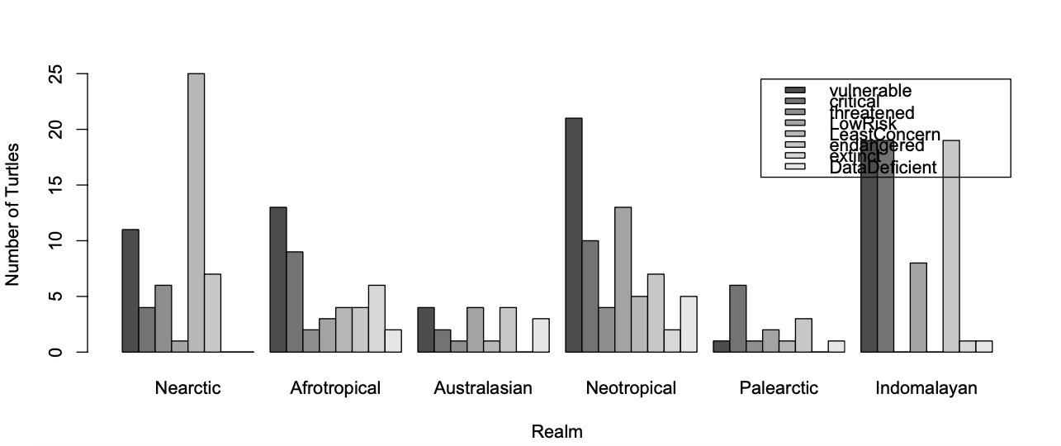

Figure #1: The bar graph above uses data from the IUCN Red List Ratings of about 260 turtles species found around the world. The IUCN breaks up the species habitats into realms and those are represented on the x-axis. The bars themselves represent the red list category that each turtle rates at based on their population in each realm. The rating include: vulnerable, critical, threatened, low risk, least concern, endangered, extinct, and data deficient.

**Discussion**

The biogeological realms of this world actually amount to 8 but turtles only live in 6 realms. The realms that the turtles do occupy include the Nearctic, Afrotropical, Australasian, Neotropical, Palearctic, and Indomalayan. These realms may play a huge role in the decreasing populations of the turtles that live in them. The Nearctic is most of North America and that includes the United States. We as a country can do a lot better when it comes to protecting species and their habitats. Species like Diamondbacks and the Desert Tortoise are losing their habitats because of residential construction in unnecessary areas. The Neotropical realm or most of South America, has also seen decreasing populations because of over populated beaches, tourism, and climate change. The Indomalayan realm or the South Eastern Asian countries have many species that are endangered or extinct and this is because of over exploitation as food and over populated beaches.

The decline in population affects the evolutionary of turtles because the pool of genes is greatly decreased. The rules that the best fit or the survival of the fittest go out the window because the causes of decline stem from climate change, habitat destruction, and being used as pets or food. Turtles have been on this planet for a long time and now they are one of the most threatened groups of vertebrates on this planet.

**References**

Farnsworth, Matthew L., Brett G. Dickson, Luke J. Zachmann, Ericka E. Hegeman,

Amanda R. Cangelosi, Thomas G. Jackson, and Amanda F. Scheib. 2015. “Short-

Term Space-UsePatterns of Translocated Mojave Desert Tortoise in Southern

California.” Edited by Jesus E. Maldonado. *PLOS ONE* 10 (9): e0134250.

<https://doi.org/10.1371/journal.pone.0134250>.

Converse, Paul E., Shawn R. Kuchta, J. Susanne Hauswaldt, and Willem M. Roosenburg.

2017. “Turtle Soup, Prohibition, and the Population Genetic Structure of Diamondback Terrapins (Malaclemys Terrapin).” Edited by Tzen-Yuh Chiang. *PLOS ONE* 12 (8): e0181898. <https://doi.org/10.1371/journal.pone.0181898>.

Message for Reviewers:

As you can see my paper is kind of lame and I plan on making it better! I am thinking of making a phylogeny with all the species of turtles in the bar graph. Also I can put in a table or another graph for the population trends of the turtles but it is hard to find data with actual numbers because turtles are hard to count. But I have whether the species are “decreasing, stable, or increasing” in population.

My one and only graph has a flaw in the legend so if you know how to fix that that would be awesome.

For the introduction and discussion, should I add more sources and info from other papers to beef it up?

For the methods, I am a little confused on what to put in here so any advice or input would be great!

Thank you for reading my very short paper, hope yours is better than mine :)